Tab 1

EnGRAM Process Summary
(Based on what we’ve seen and experienced so far)
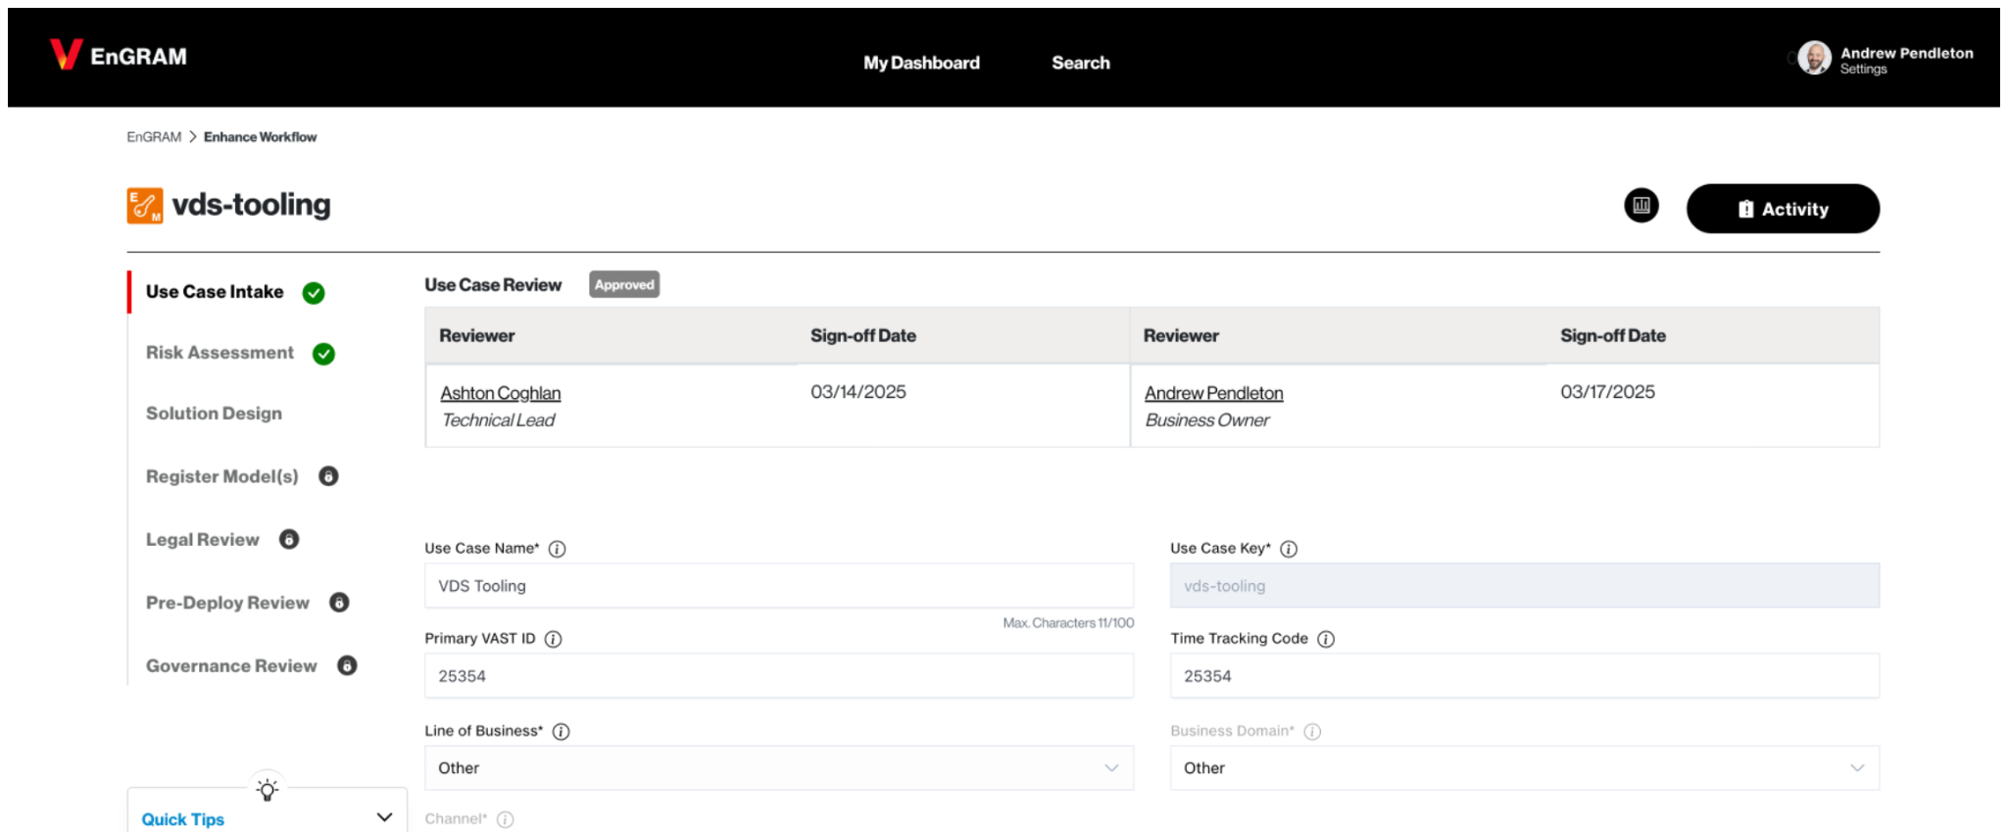
VDS AI tooling project in EnGRAM
The EnGRAM process is a multi-stage process that has many manual, human intervening steps. The VDS team initiated this process in March for an initiative focused on introducing AI into the Design workflow within Figma. There are seven bespoke steps. Not all actions within each step are documented. New requirements are given to us within each step. Two months into this process and we are on step three of seven with no clear next steps other than waiting for a team to get back to us.
The initial "Use Case Intake" phase of this governance process is the formal entry point for all AI-leveraged projects. This process requires that a "Project Owner" defines the initiative and its purpose, the specific business problem it aims to solve, and the anticipated business value (KPIs) in high fidelity with as much detail as possible. This stage requires the upfront identification and involvement of many stakeholders, including a "Technical Lead", the "Business Owner", a "Legal Reviewer", a "Model Risk Officer", and representatives from Cloud Security, Enterprise Architecture, and Responsible AI. This process requires significant coordination and administrative work before the practical exploration of an AI solution can even begin.
Following the intake, the "Risk Assessment" phase subjects the proposed AI use case to intense scrutiny, managed by the Model Risk Officer. This involves a comprehensive questionnaire designed to reveal impacts across various Verizon domains: employees, customers, government entities, societal impact, and the supply chain. The assessment dives deeply into categories such as "Harm-Benefit," "Autonomy" (including whether AI makes decisions without human oversight or if users can opt-out), "Justice" (considering accessibility and potential for bias), "Organizational Impact" (financial, reputational, regulatory), and specific risks associated with "Generative AI." Based on these extensive inputs the process follows up with 34 questions across these categories which then lead to the use case being assigned a materiality and ethics risk level. Following this stage, the project is given a “Risk Assessment Score” which then automatically triggers further mandatory actions, such as an "Independent Review" and adherence to specific protocols like an "Ethics Review" and "Explainability Report." The "Solution Design" phase, led by the Technical Lead, then requires formal Cloud Security approval and the submission of detailed design documents, including a Solution Blueprint. Given the "Material" risk designation, an Independent Reviewer must be engaged and granted access to all solution design documentation, further emphasizing the process's depth and the number of checkpoints even before model registration or a formal legal review.

Final (personal) thoughts
This multi-stage, highly detailed approval framework (evident to us having just completed the initial three of seven steps since March 2025) points to a corporate culture with a profound aversion to risk. While I believe and understand that the intention is clearly to ensure responsible and secure AI deployment, the volume of documentation, the extensive stakeholder engagement, and the sequential, in-depth reviews create a process that is undeniably long and convoluted. The risk here is that such a process heavy and precautionary system can stifle the innovation it's meant to govern. The significant upfront investment in navigating this actually discourages teams from proposing more experimental or ambitious AI projects, favoring only those with the clearest, lowest-risk profiles that can withstand the rigorous, multi-layered scrutiny. This will lead to a slower pace of AI adoption, a potential loss of competitive agility, and a climate where the perceived burden of the process outweighs the perceived benefits of exploring cutting-edge AI solutions.

Tab 2
Ashton
I'm sympathetic to Verizon’s low appetite for AI risk, but only for customer-facing experiences. We’re not built to develop innovative customer experiences–it’s not in our DNA. And so, given our brand positioning, organizational structure, and corporate strategy, I actually agree with the EnGRAM process.
However, internal platforms (like VDS) should not have to go through the same AI risk assessment process as externally-facing product teams. AI product development is too nonlinear. It requires too much “let’s see what happens!” because not even the AI experts know exactly how LLMs work, yet. So, sure, Verizon can take its time in this burgeoning arena by upping its risk mitigation efforts for externally-facing products and services. But let internal tooling teams cook!

